Box for Salesforce User Guide
Aug 12, 2024
What is Box? 2
Box Account Setup 2
Welcome email for New users 2
Sign Into Your Box Account 3
First time Logging In/ setting up 2-factor 3
Box Application Home Screen 5
Connecting Box to Salesforce 6
Accessing Files within Records 9
Accessing Account Files 9
Accessing Contact Files 9
Accessing Case Files 10
Uploading files 10
Downloading or Making Changes to Files 11
Additional Things to Consider When Using Box 11

​​

Revision # | Date | Revision | Revised By:
1.0 | 08/20/2024 | Final Version | Shannon Wright
1.1 | 09/04/2024 | Password Rest and Deactivating User | Corina Downey-Konkus

What is Box?
Box offers a cloud storage platform that provides long term file storage. Box is integrated with Salesforce to allow you to access files from within the Salesforce interface. Box folder and files can be associated to specific Salesforce records, such as Account, Contacts, and Cases. This allows you to share access to those files with anyone who has permission to access them.

This quick start guide will help you set up your Box account and connect it to your Salesforce account

Box Account Setup
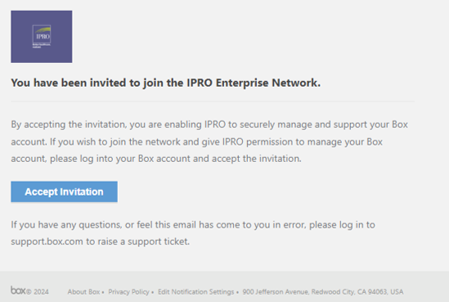
Welcome Email for Existing Users
If your email has already been associated with a Box users, look for an invitation from box to join the iPro enterprise org and do not need to create a new password

Welcome email for New users
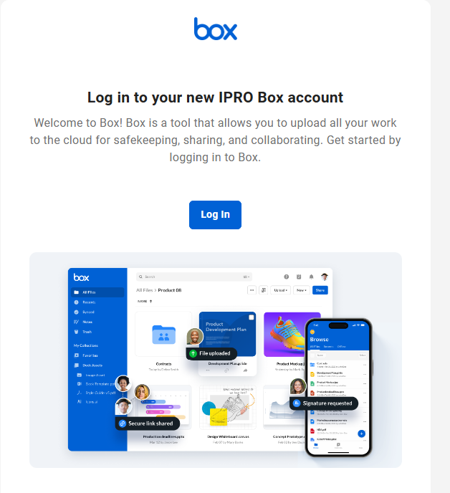
To log in for the first time, find the email with the subject “Log in to your new IPRO Box account”. This email should come from the sender “Box” and be associated with email address noreply@box.com. If you do not receive the email in your Focused view in Outlook, check in your Other view tab in Outlook. Click the login button contained in the body of the email.

Next, you will be prompted to create a new password. Remember your password, you will need it
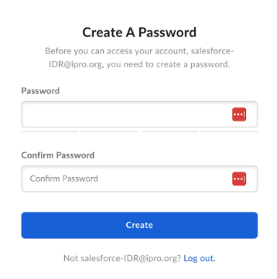

Sign Into Your Box Account
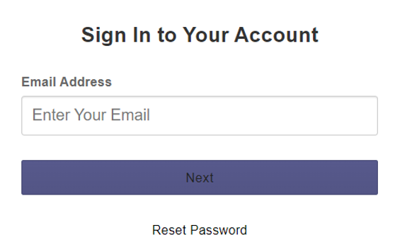
You will be prompted to sign in to your Box account by entering your email address. Enter your ipro.org email and click next. You will next be prompted to re-enter your password. 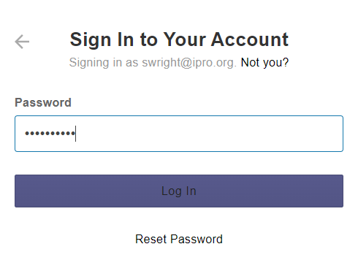

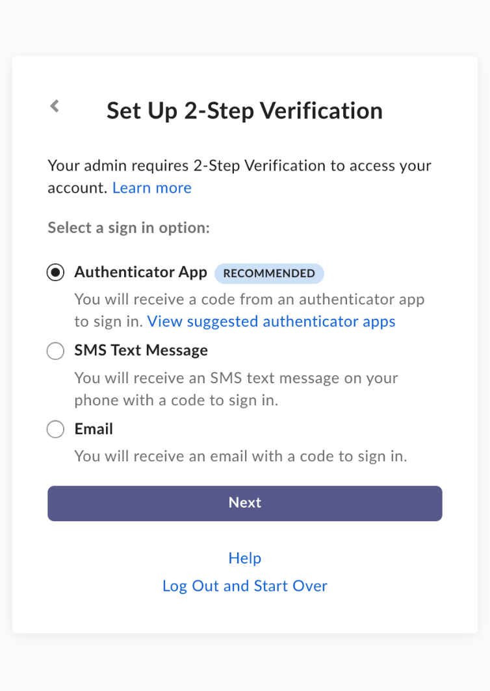
First time Logging In/ setting up 2-factor
Before you can connect this new account inside Salesforce, you must first set up 2-factor authentication. You can use any of the 3 options. Box defaults the Authenticator App as the recommended approach; however, you can use any of the 3 types of 2 factor verification. IPRO recommends using the email method.

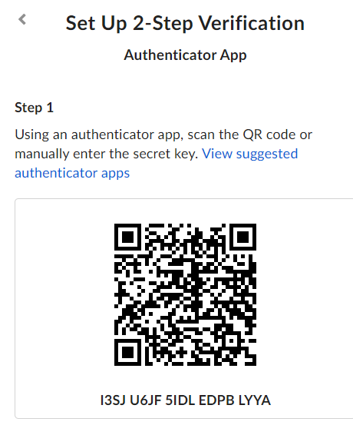
The Authentication Application will require you to install and an application for authentication.

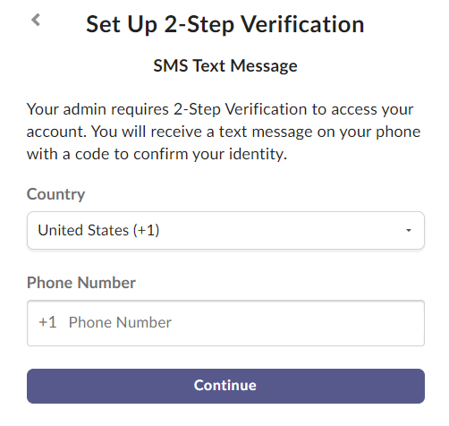
SMS Text Message verification requires you enter your cell phone number and click continue. A code will be text to your phone. Enter the code to confirm your identity.
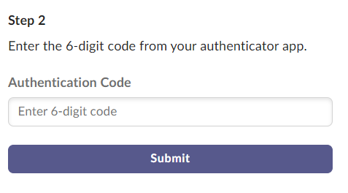

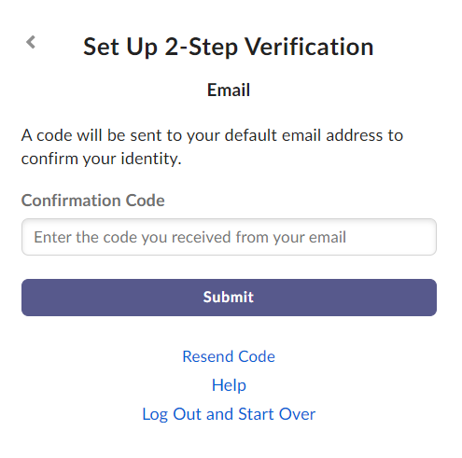
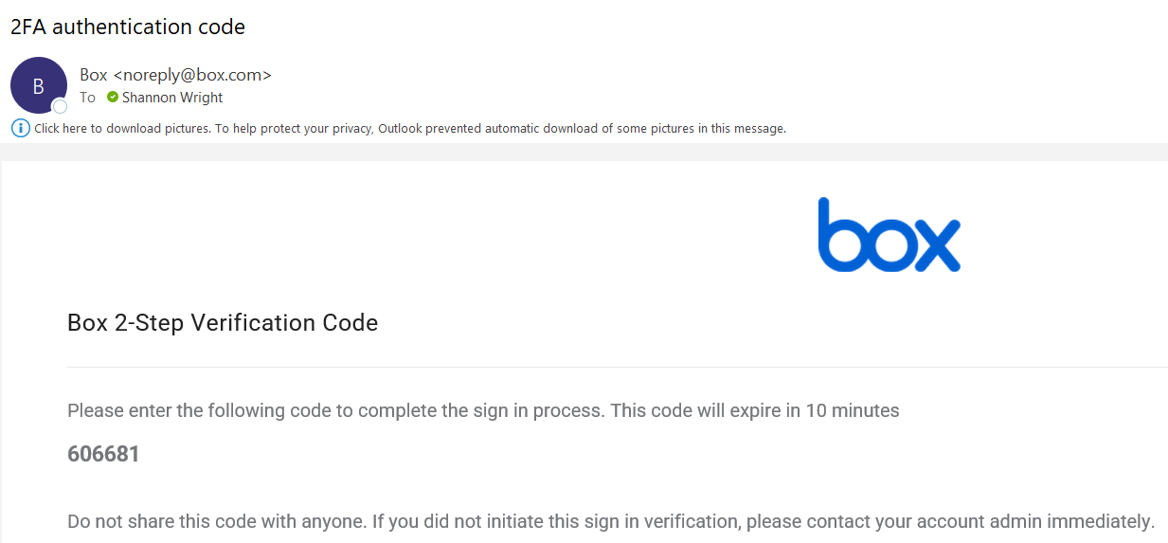
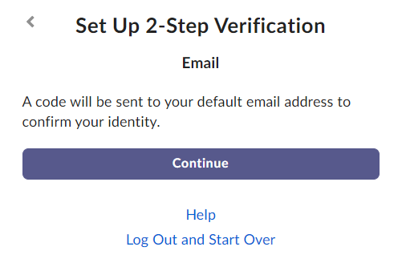
Email Verification (IPRO Recommended Method) verification requires you enter your ipro.org email address and click continue. An email will be sent to your default email address. Enter the code to confirm your identity.

Box Application Home Screen
Regardless of the authentication method used, once you are authentication you will be brought to the box application. You can now close the Box application screen.
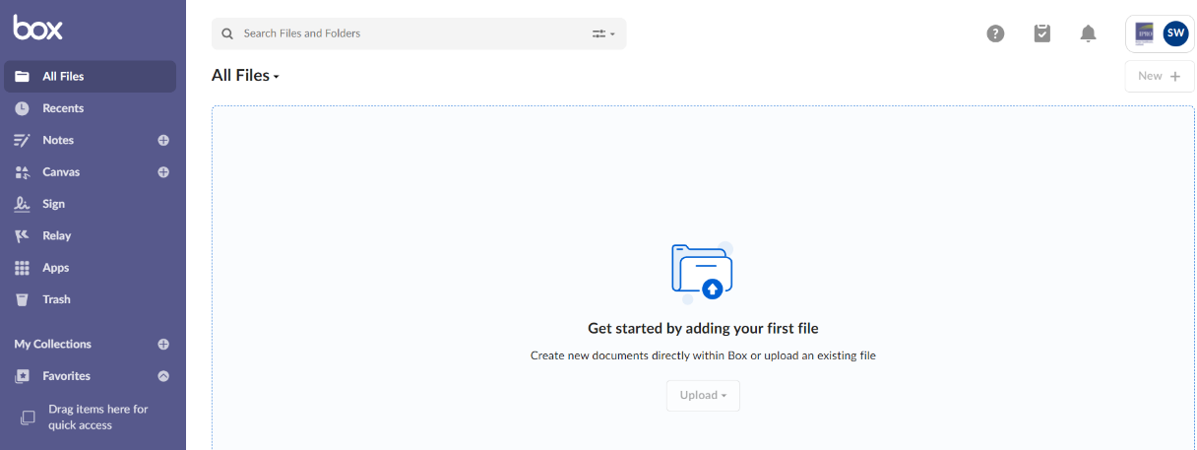

Connecting Box to Salesforce
Once you have finished creating your Box account you will need to connect your Box account to your Salesforce account to be able to access the functionality provided by Box.
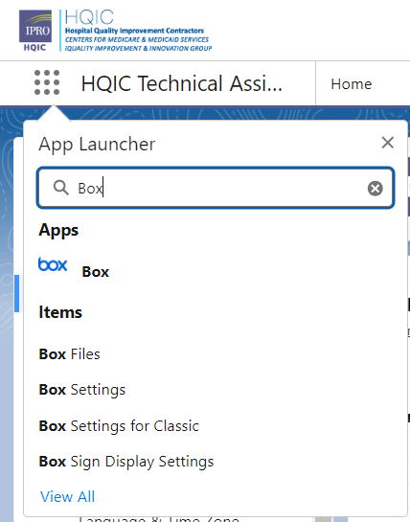
Log into your Salesforce account and navigate to the 9 dots on the top left of the screen. Enter Box in the search field and click the Box application.

Select the Box Settings tab at the top of the screen.
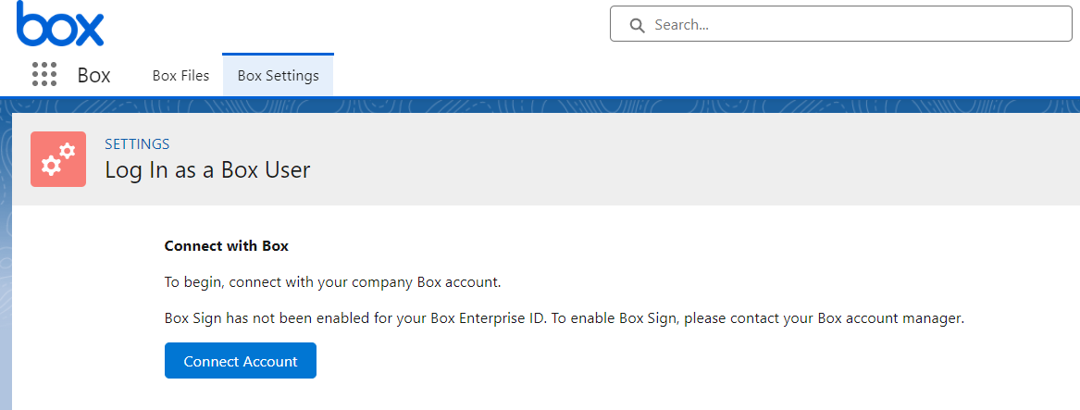

Next, click Connect. You will be prompted to log into your Box account using your Box password and using your preferred 2-factor authentication method.
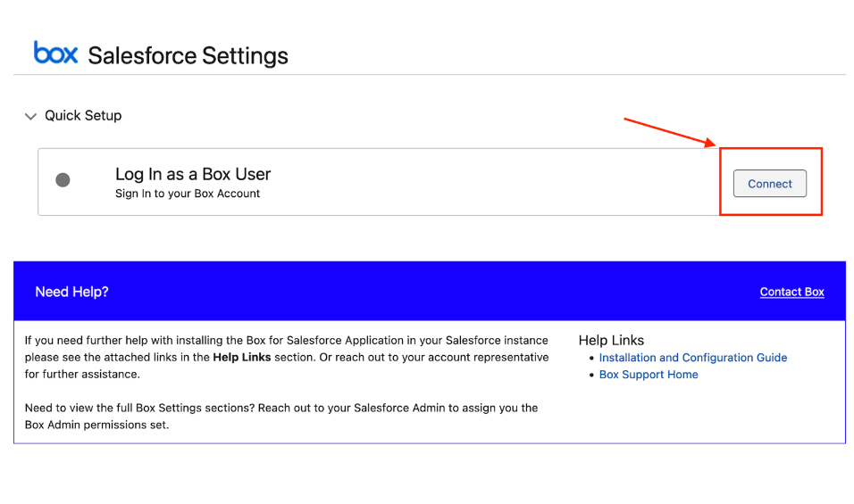
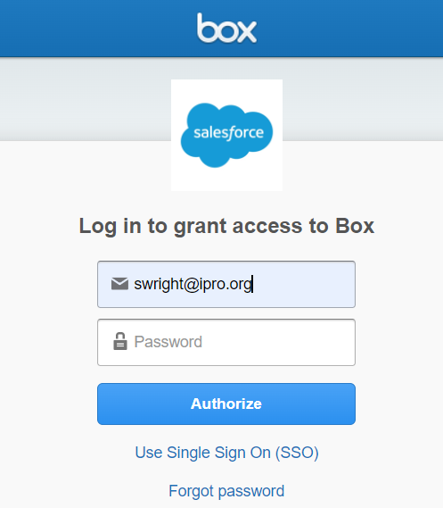

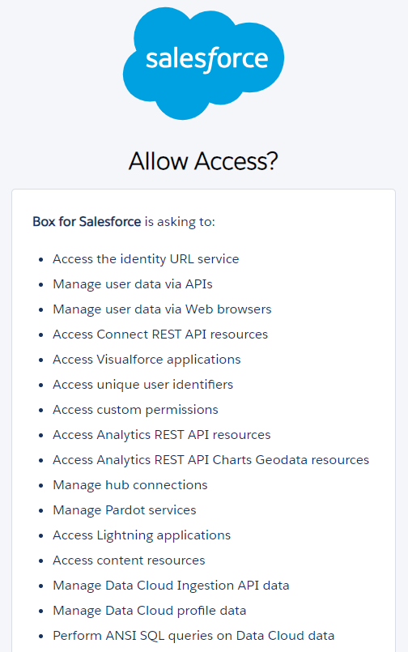
You will be prompted to Allow or Deny Access. Select Allow.
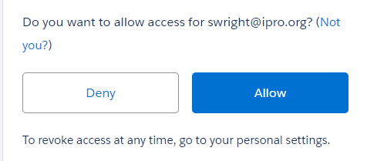

You will be redirected to the following screen confirming your Salesforce connection with Box. You can navigate back to the 9 dots and search for the application you work in.
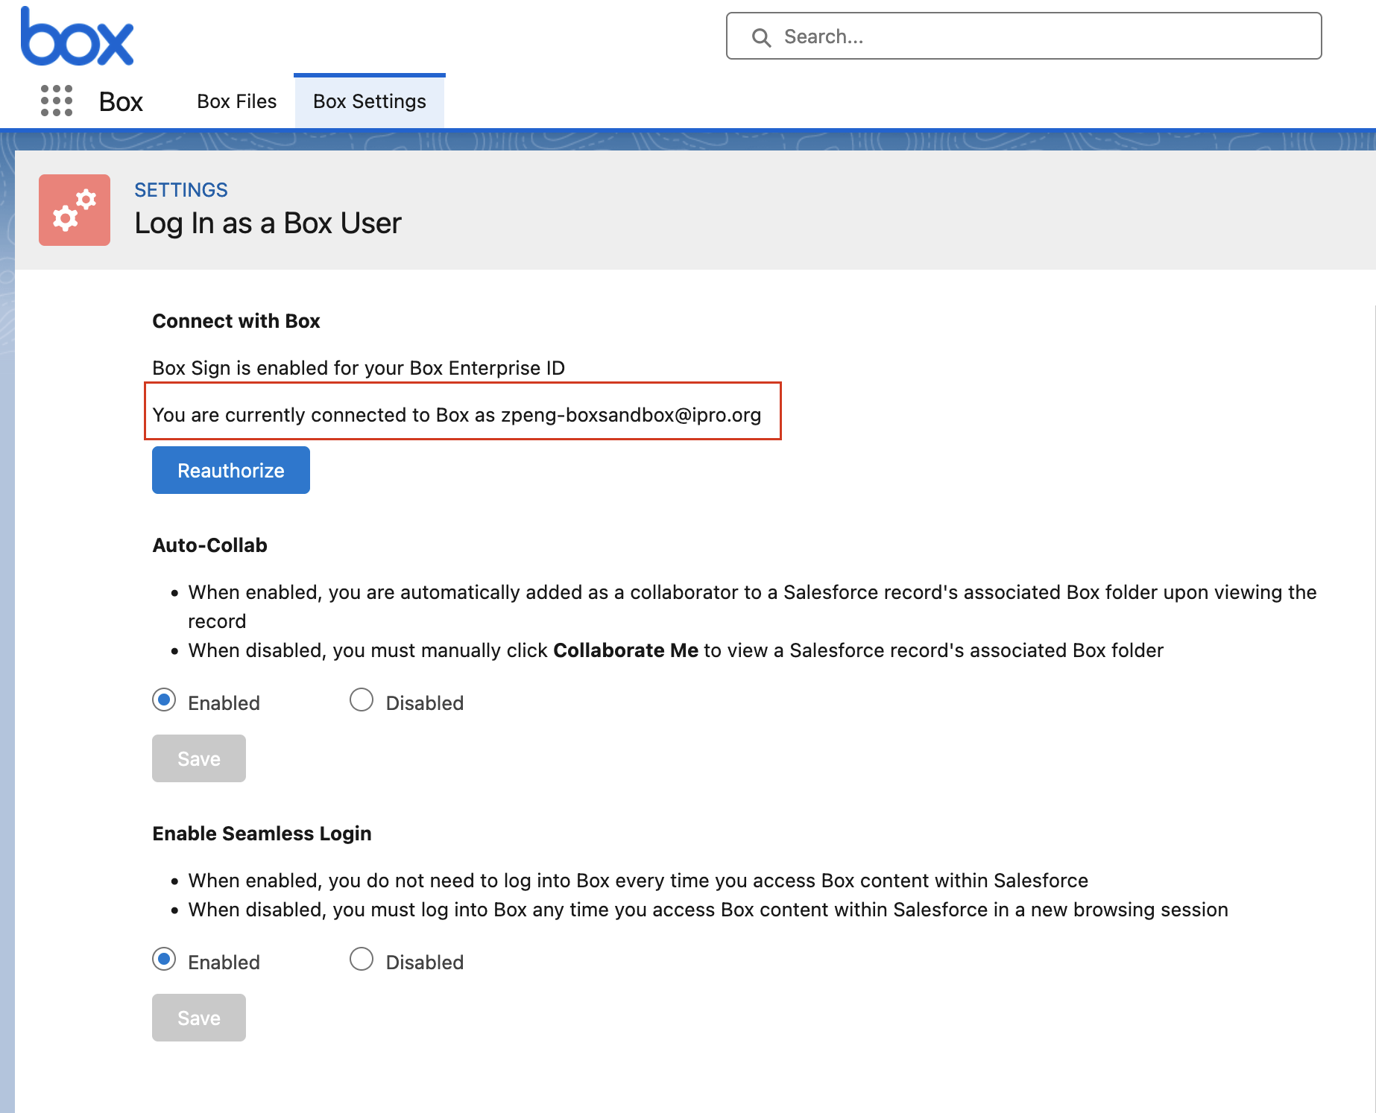

Accessing Files within Records
Users can access and store files in Box from Salesforce on the Account, Contact, or Case level.

Accessing Account Files
On the account page layout, there will be a tab for Files. This tab is used for storage of Box documents that are viewable by all departments
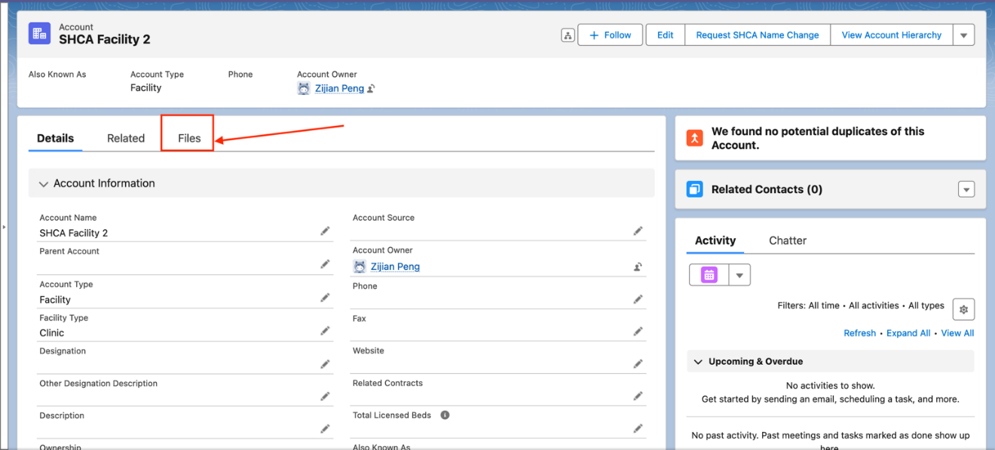

Accessing Contact Files
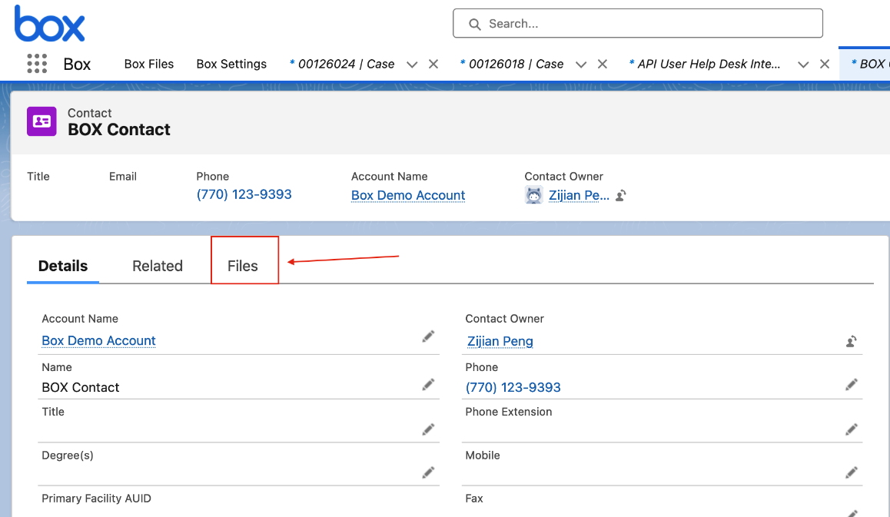
Just like on the account page, the Contact page layout will also have a tab for Files. This tab is for storage of Box documents that are viewable by all departments.

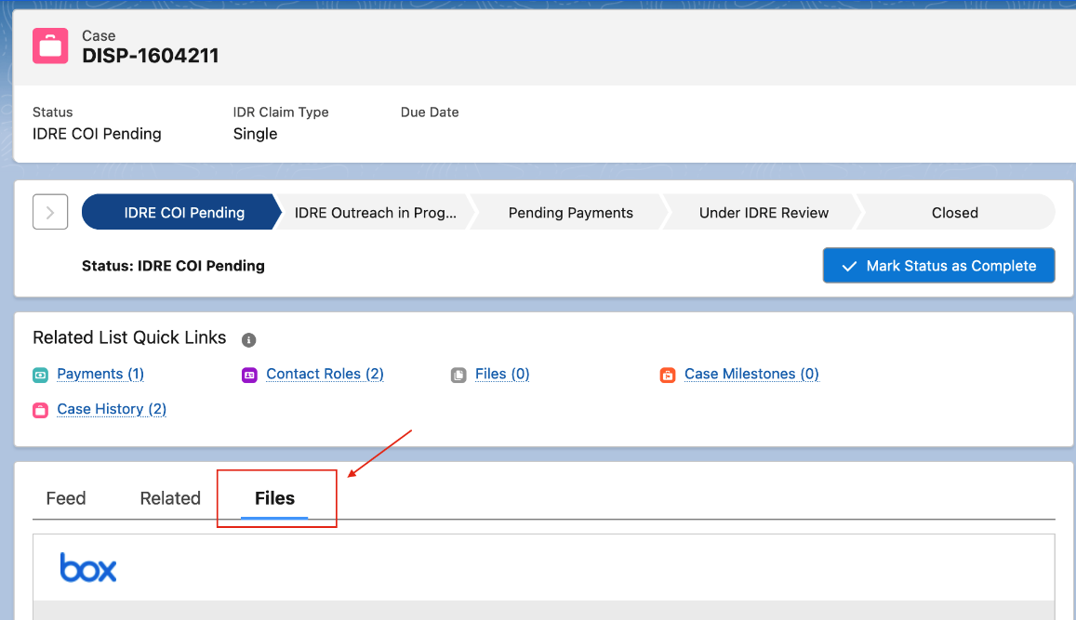
Accessing Case Files
The Case page layout contains a File tab. Files stored on the Case page will only be visible to others within your department who also have access to the case. NOTE: Files uploaded to a case are private, they are able to be accessed only by others in your department with the same access permissions.
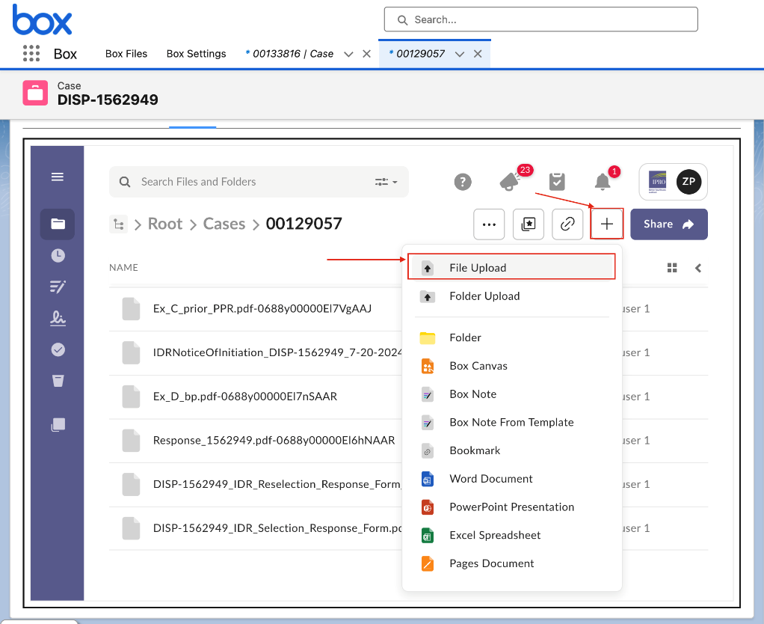
Uploading files
To upload files click the plus button on the top right of the Box component

Downloading or Making Changes to Files
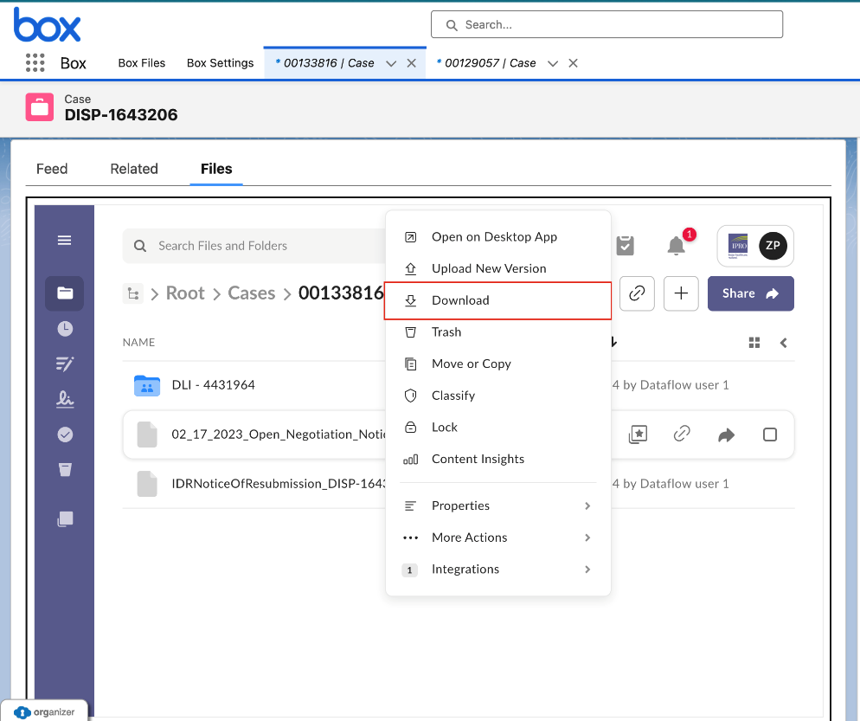
To download files, click the ellipsis to the right of a file for more options, then click download. In this area you can also:
- Open the file in the desktop application
- Replace the current version by uploading a new version
- Move or Copy the file to a new location
- Classify the file
- Lock the file

Additional Things to Consider When Using Box
- The maximum file size is 150GB per upload
- The user's Box permissions are determined by permissions in Salesforce:
  - Read/Edit access on Salesforce translates to an Editor role in Box.
  - Read-only access on Salesforce translates to a Viewer role in Box.
- Consider standardizing naming conventions so it is easy to locate files in Box.
- Sharing files within box is explicitly disallowed. When you click the native share button up top, it will navigate you to the sharing page. You will receive an error saying you do not have permission to invite collaborators. To share a file, you must download the file and then send it outside of the Box application. Be sure to follow all guidelines around sharing files if there is PII or PHI.
- You should only be accessing Box through Salesforce, logging in and using Box outside of Salesforce is currently prohibited and go against IS security policies.
- Box has a password expiration requirement of every 60 days. If you are unable to connect to Box from Salesforce and it has been approximately 60 days since you created your password, you may need to reset your password in Box. To reset your Box password, follow these steps:
  - Go to the website https://app.box.com/reset
  - Enter your email address and click “Reset Password”
  - Check your email for the link to reset your Box password. Be sure to check your SPAM folder if the email doesn’t appear in your inbox.
  - Click the Box link and follow the instructions.
  - Please note: The Box link expires after 3 hours. If 3 hours have passed since you requested the link and you did not click on it, you will need to redo these steps and request a new link.

Manager Consideration for Managing Box Users
- When a New User license is requested for Salesforce, it will be assumed unless otherwise requested, that a Box license will also be needed. If your user will not need to access Box for document storage, please state so in your New User request.
- For a document to be visible within Salesforce, the ‘owner’ of the document which by default is the person who uploaded it, must have a current active license.
- When a manager requests that a user’s access be deactivated within Salesforce, it is necessary to also include a current user to whom all the Box document ownership should be transferred to ensure access to those documents continues.
  - Example: Case Manager Ashley has put in her two weeks notice. When her manager, John, completes the Salesforce User Deactivation request, he requests that Ashley’s Box documents be reassigned to Jennifer for the team to continue to have access to them.

